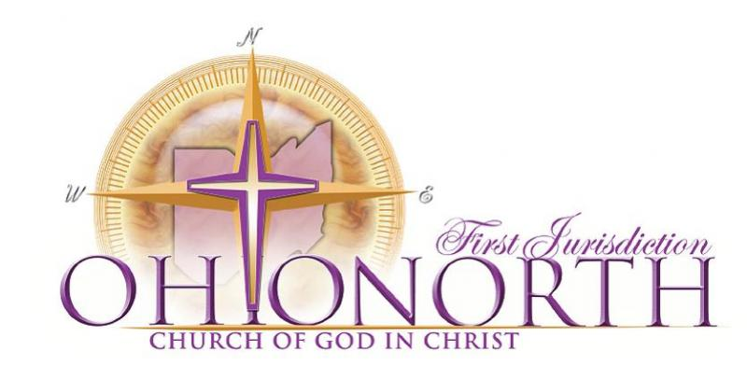
Enrichment: Mining the Text (Circular Study)
By Pastor Terrance M. Curtain Jr.

Discovery comes as a result of inquiry

Just because you know how to dig…doesn’t mean that you know what it means to mine.
What are you trying to discover?
Where to dig?
What tools to use?
What is the method of mining?

No wasted words, every name, word, every construct, every relationship has some meaning

Context
Author
Author’s Purpose/Genre
Look Fors – “Wet Spots”
Literary Structure
Repeated/Emphasized Words
Repeated Themes
Terms of Theophany
Similar Concepts in other Scriptures/ Story parallels
Instances/ similarities is Nature
Historical Similarities
Grammar
8 Ls

Perspective
Protagonist
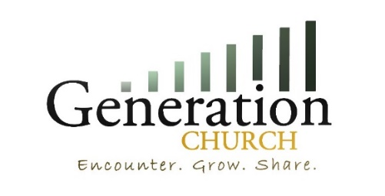
Antagonist
Hearers
Observer
God’s

Enrichment: CBT’s (Consistent Biblical Themes)
By Pastor Terrance M. Curtain Jr.

God has been CONSISTENT

