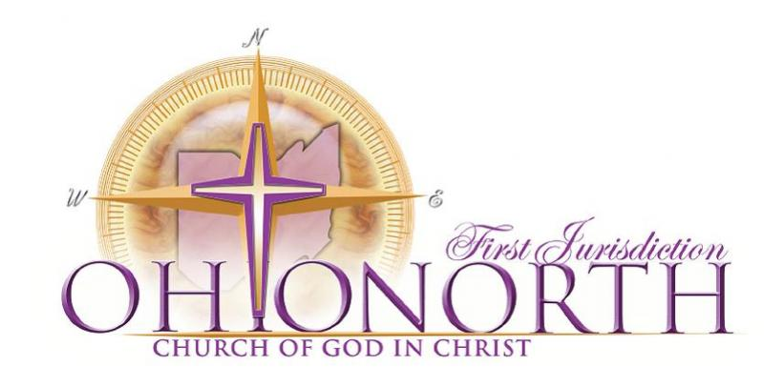
Ordination Syllabus
Class of 2019
www.ohionorthcogic.org/
ohionorthcogicordination@gmail.com

The Scriptural Basis for Ordination
“For this cause left I thee in Crete, that thou shouldest set in order the things that are wanting, and ordain elders in every city, as I had appointed thee: If any be blameless, the husband of one wife, having faithful children not accused of riot or unruly. For a bishop must be blameless, as the steward of God; not selfwilled, not soon angry, not given to wine, no striker, not given to filthy lucre; But a lover of hospitality, a lover of good men, sober, just, holy, temperate; Holding fast the faithful word as he hath been taught, that he may be able by sound doctrine both to exhort and to convince the gainsayers.” - Titus 1:5-9

The Mission of the Board
To further cultivate relevant, effective, disciplers, through a standardized process of training, and assessment, that establishes and presents a collegial brotherhood of ready candidates to the Bishop for ordination.

The Application Process
- Obtain Pastoral Letter of Recommendation on official church letterhead
- Complete the COGIC Credential Request Form
- Complete the COGIC Screening Application
- Complete the Online COGIC Sexual Misconduct Training ($15 fee) (save certificate as .pdf)
- Complete BCI Background Check via (Cornerstone Company)
- $200 fee Money Order
- Mandatory attendance Ordination Orientation (recommended with Pastor)
**Please Scan and save all forms as PDF**

2018 Important Dates
February 2rd, 2019 – Orientation @ Generation Church (365 East 156th St. Cleveland, Ohio 44110) 11am
March 28th, 2019 – Sessions I and II @ Worker’s Meeting (Cleveland, Ohio) 9am-2pm
May 19th, 2019 – Session III and IV @ Generation Church (Cleveland, Ohio) 9am-2pm
July 24th, 2019 – Written Examination @ Holy Convocation (Columbus, Ohio) 10am-untill
July 25th, 2019 – Project Presentation and Interview @ Holy Convocation (Columbus, Ohio) 9am-untill
August 17th, 2019 @ 12 Noon– Ordination Service (Columbus, Ohio) *Class A Vestments Required

Required Free Texts (PDF’s available)
Church of God in Christ Theology and Doctrine Student Book (downloadable from website)
Church of God in Christ: Standardized Ordination Curriculum (downloadable from website)
Church of God in Christ: Official Manual (downloadable from web)

Required Texts
Christian Theology by John H. Sailhamer 0310500419
Bishop C. H. Mason and the Roots of the Church of God in Christ by Ithiel Clemmons 978-1562294519
Church of God in Christ: Official Manual
Understanding Bible Doctrine as Taught in the Church of God in Christ (RARE)

Communication and Technology Requirements
All Communiques will be distributed via GroupMe Group Texting App.
Candidates must be able to Word Process, Access Internet and email, and have texting capabilities.

Class Session Attendance
Is for enrichment, encouragement, and enlightenment. Attendees will receive extra credit points toward their grade.
Module Assignments Submission
Every Completed Module Document file need to saved as
(LastName-ModuleNumber-Date) for example (Curtain-Module2-010419)
and emailed to ohionorthcogicordination@gmail.com by the due date

Final Ministry Project
Declaration of Project – Due May 24th
A statement declaring the general purpose of the ministry and the social ill that it addresses.
Pastor Presentation – To be made before July 25th
Present your Ministry Project to your Pastor, make final adjustments.
Have Pastor Sign and Date your Project Signifying that it was presented to him.
Presentation of Project – July 25th
Presentation is to be made with use of technology (PowerPoint, Video, audio)
Hardcopies of Presentations are to be made for Bishop Cook and the interviewing Ordination Board Members.
Steps
- Discuss with your Pastor regarding the social ill that the LORD has called you to address, and how that aligns with the vision of the ministry.
- Address a “social ill” within your community.

Mis-education in schools
Mass Incarceration
Eugenics through Abortion
Gang/Gun-Violence
Human Trafficking
Media Influence/accepted mediocrity
LGBTQ Lifestyle
Pornography
Finances and Investments
Genocide
Chemical Dependency (Drugs, Alcohol, and Tobacco)
Bullying
Obesity and Health Awareness
Socio-Economic Oppression
Hunger and Homelessness
Capitalism
Domestic Violence
- Research- Read research articles, books, call local politicians, view a documentary or film, etc. to broaden your insight on the issues at hand.
- Write a short 5 paragraph essay - explaining WHY there is a need for your ministry, and HOW that ministry would function with references to research.
Paragraph One – Introduction, statement of thesis and 3 reasons why your thesis is true.
Paragraph Two – Discussion of Reason #1
Paragraph Three – Discussion of Reason #2
Paragraph Four – Discussion of Reason #3
Paragraph Five – Restatement of thesis, reasons, and the conclusion that has been made.
- Create a Ministry Plan – Plan the launching of a ministry (using the electronic template on the website)
- Present Ministry Plan– Present Plan to the Pastor and the board. Use technology, presentations slides, and handouts in the presentations. PRESENTATIONS WILL BE SUBMITTED TO BISHOP COOK.

Written Examination – Will be based on the “75 Questions”

Board Interview – Length of the interview may vary
- Dress Code – Black Pants, Black Shoes, Black Tie, White Shirt.
- Hardcopy of Bible, Bottled Water

Ordination Recommendations to the Bishop from ONFJ Ordination Board
Board Recommendations will be determined by the following components
  - Completed Modules – minimum of 70% of modules completed.
  - Written Examination – minimum score of 70% required for recommendation.
  - Ministry Project Presentation – Average Rating of “Proficient” or better on Scoring Rubric
  - Board Interview – Unanimous Recommendation of the Board –
*The ONFJ Board reserves the right recommend or decline to recommend candidates based on a collective discretion of the results of the Modules, Examination, Presentation, and/or the Interview.
Module | Pages in textbook | 75 Questions / Bis. Mason & the roots of the COGIC | Pacing  Due Date
Module #1  75 Questions | 1-20 | 75 Questions 1-28  Read and Outline - About the Founders | 2/11
Module #2  75 Questions | 21-40 | 75 Questions 29-45  Read and Outline: The Formative Years | 2/25
Module #3  75 Questions | 41-72 | 75 Questions 46-58  Read and Outline: The Roots of the Azusa Street Revival - A New Spirituality | 3/4
Module #4  75 Questions | 73-81 | 75 Questions 59-66  Read and Outline: The Holy Convocation – Moving into the City | 3/11
Module #5  75 Questions | 101-123 | 75 Questions 67-75  Read and Outline: Mothers Roberson and Coffey – Pioneers of Women’s Work | 3/18
Module | Pages in textbook | COGIC Theology and Doctrine | Pacing  Due Date
Module #6  COGIC Theology and Doctrine | 5-24 | Read Unit 1, Unit 2, and Unit 3  Create Document: Define Key Terms, Answer discussion Questions,  Read Sailhamer Assigned Reading  Wagner-Houts Spiritual Gifts Assessment | 3/25
Module #7  COGIC Theology and Doctrine | 24-39 | Read Unit 4, Unit 5, and Unit 6  Create Document: Define Key Terms, Answer discussion Questions, Read Sailhamer Assigned Reading | 4/1
Module #8  COGIC Theology and Doctrine | 40-71 | Read Unit 7, Unit 8, Unit 9, and Unit 10  Create Document: Define Key Terms, Answer discussion Questions, Read Sailhamer Assigned Reading | 4/8
Module | Pages in textbook | Ordination Standardized Curriculum
Module #9  Overview & Ordained Elder  Statement of Faith | 4-53 | Glossary- Define all bolded and key terms  Statement of Faith T-Chart – Prepare a document containing a “T” chart that compares another denomination’s affirmations to those made in our Statement of Faith. | 4/15
Module #10  Old Testament | 54-71 | Glossary- Define all bolded and key terms  OT People Profile - Research an ancient culture or people mentioned in the OT, and create a profile sheet containing the following information: Name, Names of people, Bible Passage, Geographic Location, Language, Religious practices, Times of existence, other interesting facts. (template on website) | 4/22
Module #11  New Testament | 72-84 | Glossary- Define all bolded and key terms  NT Genre Chart – Make a chart that: describes the differences in NT genres, and categorizes the NT books.  5 paragraph Essay (pg. 84) – Choose a question to respond to | 4/29
Module #12  Church History Theological Knowledge | 85-120 | Glossary- Define all bolded and key terms  Short Essay Questions (3-5 sentences) - Page 100/1-2 | 5/6
Module #14  The Polity  The Ordination | 121-155 | Glossary- Define all bolded and key terms  COGIC Flow Chart – create a COGIC Organizational Flow Chart  8 L’s Chart #2- Complete an 8 L’s exegetical chart | 5/13
Module #15  Preaching Course | 156-167 | Glossary- Define all bolded and key terms  8 L’s Chart #1- Complete an 8 L’s exegetical chart  Write a Sermon – using the exegesis from the 8 L’s chart. | 5/20
Module #16  Spiritual Formation  Practical Counseling  Women in Ministry | 168-215 | Glossary- Define all bolded and key terms | 5/27

Board Contact Information
Pastor Terrance M. Curtain Jr., Chairman - 216-534-0083
Pastor Samuel Canty, Secretary – 513-259-6082
Superintendent Ross Johnson – 330-507-9701
Elder Willie Templeton Jr. – 937-361-9492
Elder David Reliford – 330-327-0619

